GCS Operator Manual


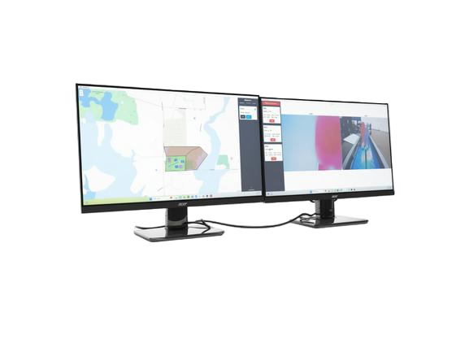

By the 2025-26 GCS Team

NGCP Mission Planning 3
Keep In / Keep Out Zone 4
Requirements 5
Risk Mitigation Plans 6

NGCP Mission Planning
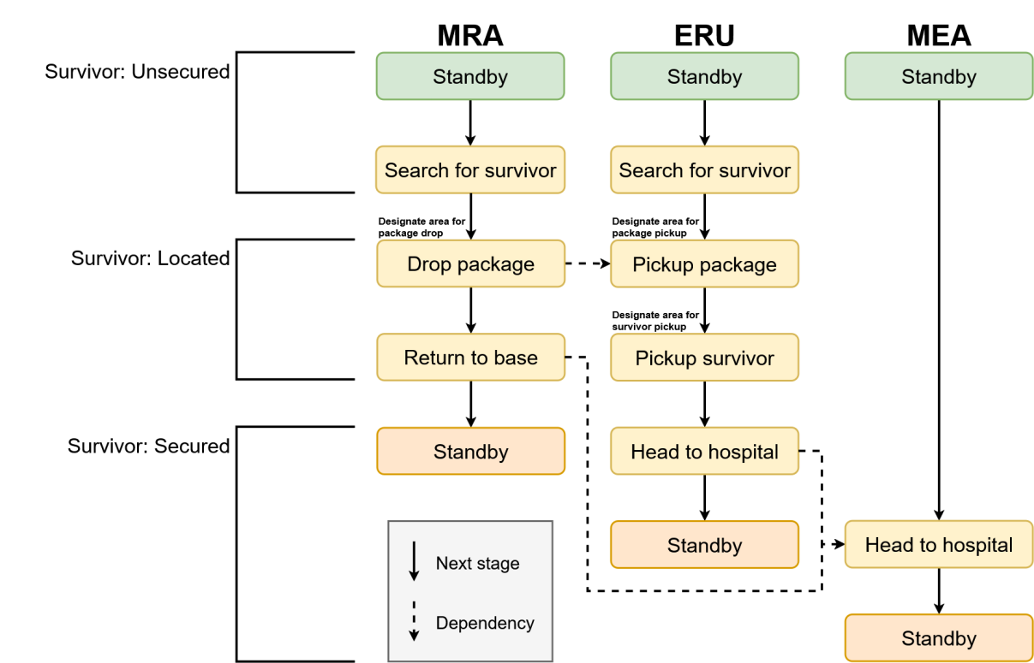
The GCS operator will create each stage for each vehicle. All stages will be manually progressed to the next using the Next Stage button.
Most stages will have a target for the location, which is what the Search Area will be used for. The GCS operator will create the Search Area for each stage. For specifically the Drop Package, Pickup Package, and Pickup Survivor stages, the operator needs to wait for the survivor’s coordinates during the mission. For example, after the survivor is found, the coordinates of it will be transmitted to the GCS. Based on these coordinates, the GCS operator will create a Search Area for MRA’s Drop Package stage. Ideally, this would be near, but not on top of the survivor’s location. The other stages with small footnotes have a similar process.
The “Dependency” arrows are for reference, as everything is progressed manually. For example, the GCS operator should only move ERU from Search For Survivor to Pickup Package after MRA moves on from Drop Package.

Keep In / Keep Out Zone
The following image is the keep-in/keep-out zones that will be created on Demo Day:
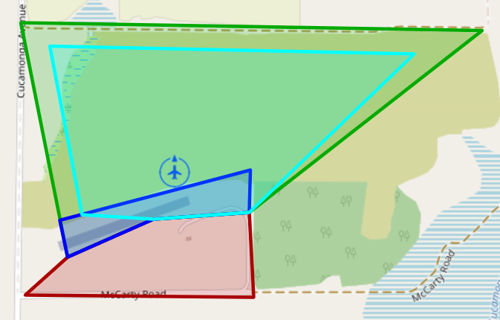
When creating zones (including vehicle stage search areas), the polygon can only have a maximum of 5 vertices. This image shows a keep-in zone with 5 vertices.
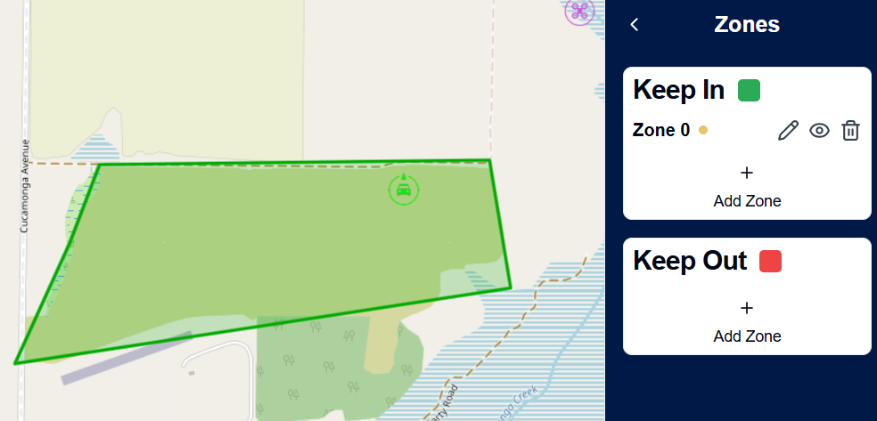
Clicking the pencil icon will edit the polygon, allowing for each vertex to be moved.
If the polygon has less than 5 vertices, there will be an additional joint that can create a new vertex. This will continue to show if a 5th vertex is created, but it will not allow a 6th vertex to be created. This image shows a keep-in zone with 4 vertices in edit mode.
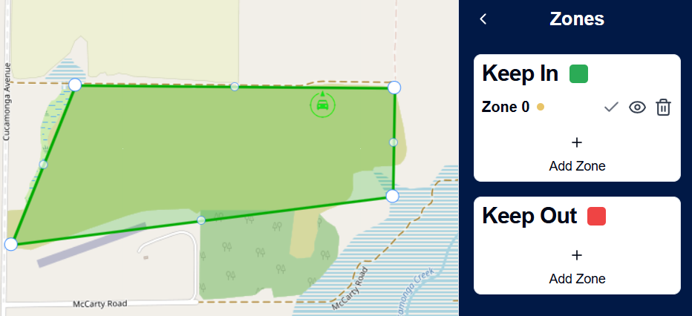

Requirements
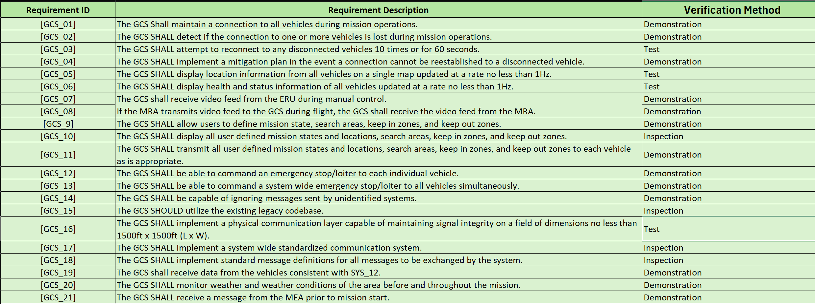
Note about GCS_20: Weather condition is monitored on the Camera Screen. The values will turn from colors Black > Yellow > Red, corresponding to Normal > Warning > Unacceptable (not suitable for mission).

Risk Mitigation Plans
